**Chapter One**

**Introduction**

In this chapter will emphasis the physical structure and the background of Al-Husseini Fuel Station Company including the information of their history briefly, as well we planned the problems and appropriate solutions will be used for solving and searching any tangible gap and also their scientific solution.

Also, this chapter will focus on the vision and mission of company specially, how the company reaches their goals in the future, also we will mention it some problems which faced this company since the establishment and our group we implementing an appropriate solution for these problems.

The general objectives for creating this software is how to manage the employers time (means, the time was entering and time was exit the workers at their task), and how they manipulate their company and the theoretical background along the project management occupation will be wisely considered.

1. **Background**
   1. **Organization background:**

Al-Husseini Fuel Station is a company that sells fuel and lubricants for motor vehicles, which locates at Ahmed Dhagax district, Near Cosob playground .It was established in 2019 at Hargeisa, and the owner who established has a citizens Somaliland.

The initiative of the establishment of this company started after long research for the adequate location. Several years later the company has expanded and have many branches, and the head office is in Hargeisa and there are working about many peoples, also there is annual turnover.

In addition, Al-Husseini Fuel Station Improved their serves community as well, and their employers were become high effectively, and well trained to perform the task as well as. Also Al-Husseini Fuel Station works with several partners to improve their quality of the services.

### Vision**:** Every enterprises or tasks that initiative there is a lot quit vision and goals and also there is well prepared plan at side of Al-Husseini Fuel Station wants to reach their goals in the future.

The owner of Al-Husseini Fuel Station had set many visions in order to achieve the company goals in the next years become and future and how they accumulate their branches all the country and they intensify how reduce the unemployment in this country.

Mission: The ambition of Al-Husseini Fuel Station is how to accumulate their services and performing a highest quality services absolutely prices to sell and every customer can available with their demand , And also they exerts how to improve their daily work job to attract their customers.

## Problem Statement

This project will identify the common problems that faced in this company.

1. It’s very difficult, to know what inters and out of our company.
2. This company have many branches, therefore it’s very difficult to do the workers their work in a series way.
3. They didn’t have any software application to manipulate their work.
4. The main problems is , it’s very difficult to remember the number of pages that was written the customer information Because, they written the data in the book and takes up a lot of time to look for the information of the customer , sometimes the book can be lost or be wet.

## Proposed Solution

Our group, when they sharing the problems which faced this company we made this software to solve their problems and manipulate their work.

1. We made this software to control and manages what inters and out of this company
2. This software will help us the employers to do their work in a series way
3. We are making this company a software which help of a lot of tasks.
4. This software also help us this company how to know the data of the customer in a simple way.

## Project Goals and Objectives

### **General Project Objectives:**

The general objectives of this project will identify as the following, lets us observe the following problems;

* Certainly, this system should manage and save the asset of the company.
* This system will be reduce the time loss of handwriting.
* This system will accumulate the economy of this company, surely.
* This system able to display the information of one customer have been done order with using simple way and didn’t takes up any time to report the new customer.
* This system should able to prevent the data redundancy.

### **Goals Objectives:**

The goals of this project is to hold or store and save all the information of the company also get back the information create reports and delete any reports that they didn’t need the employer of the company And how to covering the needs in the company activities and our self there is encouragement to help our community also we get a lot quit of experience skill how to making software application instantly and we should increase our skills, if Allah allowed.

* 1. **Scopes of the project**

There are many companies in our country and each of them are uses their own management systems, but we select Al-Husseini Fuel Station in our project to be change the current system with the new proposed system and the scope includes activity listed below: -

* Records and view Customer, Employee and fuel details.
* Update records of the data.
* Generate a full report as the user needs, generated by date and time,
  1. **Expected Outcome**

At present, technology israpidly growing. Thus, we expect this project to remove the old or manual system that the organization uses and replace it with the computerized system. And the computerized system allows to reduce the amount of time spent on searching different types of information by changing the use of the methodology of the case of the problem, and to bring a better way by keeping their confidentiality. The project fix problems that deals with the statement of the problem accordingly and produce new, easy, save and flexible prison controlling and monitoring system

# CHAPTER 2

# LITERATURE REVIEW

This section reviews in depth the adoption of fuel Station Management System with prominence on previous studies regarding the current development in management system for easy management of account inventory, records etc. A comprehensive literature review is conducted on fuel Station Management System to access the challenges, determine the advantages and also to implement the adoption of fuel station management system.

# Fuel Station Monitoring and Management

This reviews the studies conducted on fuel station monitoring and management. Most researchers conducted studies to understand the day to day running and monitoring of the financial records of a Fuel station. This subheading reviews previous studies.

Muhamad and Kodrat (2012) conducted a study on management system for gas station inventory control. The aim of their research was to build an inventory control system. They designed a system that manages ordering and control the inventory of gas using the waterfall model which consists of system analysis, system design, system implementation and testing programs. After testing the system, they found that management system for inventory control increases the security of gas station and also provide effective tracking of the inventory.

Maheshwari et al. (2014) conducted a study on resource planning system for petrol station to integrate the old pattern of manually keeping records on the day to day running of a petrol station to an automated way of using one computer. It is hard for the supervisor to track the daily records so this study introduced an easy way to maintain daily records. In this study, there are several forms for different purposes, one which is inventory management, to help the supervisor find detailed data on the daily records. there is also a module named product cost in which the cost of each product is displayed. A module named staff management in which the information of each staff working in the company can be viewed. All these modules are secured with password to provide full safety of classified records. There are many more forms in this project that makes petrol station easy to maintain (Nathwani and shah. 2014).

Ali et al. (2015) Developed an automated fuel management system that can keep up the records of the petrol stations. The results from this system prints out a receipt consequently after each transaction and can track transactions from remote areas by means of internet. In the meantime, this framework can store data in the database that can generate every day to day, week by week, month to month and yearly business reports in ireport. This management platform is increasingly productive, low cost and efficient compared to existing systems likewise encourages the fuel station to become faster and lessen fraudulent.

Okemiri et al. (2016) conducted a review to solve the issue of corruption in petrol stations, missing files and documents, time inefficiency due to manual processing, inaccurate inventory, unprotected data and poor storage. This study further tackle to issue of fraud amongst staffs, unapproved access to classified documents and information, mismanagement of petroleum product. This system gives right to privacy and secrecy in reducing inventory shortages of staff corruption and funds mismanagement. The platform also monitors the activities of all staffs through the attendance inventory included in the system.

Areeg et al. (2017) focus on the monitoring system to Track and understand the changes which takes place in petrol stations. Their study further explained in details how effective and useful remote monitoring and data collection system is essential to collect data from the petrol tank storage. In this study, a monitoring device was built on the raspberry- pi computer to send information about the level of fuel in the tank in real time through a sensor and stream it live to the site and then upload the data to a web based application where it can be accessed anywhere and at any time through the use of internet. In this study, the administration of monitoring systems in view of internet of things technology to secure the tower sites from theft and give protection to remote locations (Siddig et al., 2017). Their study is aimed at measuring the fuel tank level that can be accessed on the web based platform and at the same time, the management information system can store information about the day to day transaction records in the database and can also generate monthly and yearly reports from the database at any time.

Kaushik et al. (2017) design and developed an automated fuel station management system to eradicate the disadvantages of the present system. This study result to cashless transactions and an authorized system to help boost the country financial status. The need of

fuel is becoming more and more important because day by day, there’s rapid growth of machines and automobiles that depends solely on fuel to perform. This study makes me understand that the system will enable petrol station to function faster and effectively at a very less time and also eliminate fraud in fuel station

Chefi and Nasr (2017) conducted a study that examined periodic petrol station replenish problem. The aim of their study was to determine how effective management system can solve problem of shortage due to replenish problem. They designed a system that tracks the quantity and inventory of the fuel available in the tanks using the mathematical optimization model. At the end of their study they found out that the use of management system for fuel tracking, monitoring and management increases efficiency and reduces shortage of petrol stations.

Raghupathi (2017) conducted a study to implement automation petrol bunk management with the use of smartcard reader. The aim of this is to completely abolish the need of human interaction to dispense fuel and also to avoid loss or shortage of fuel. The study further explained that the smartcard is used to complete transactions in essence, when fuel has been dispensed, an automated bill will be printed out showing the date, time and amount of petrol bought. Surjandari et al. (2017) conducted a study aimed at solving a planning problem of petrol product delivery. The problem of haulage has been a problem in petrol station management whereby it’s difficult to get a truck to load petrol products from assigned depots and deliver in the stations, so this study used the Tabu Search algorithm to solve the problem to determine the available truck for delivery and designing routes to deliver petroleum products at minimized cost.

Janani (2018) focused on petrol bunk management system with prepaid card using GSM Technology. His study aimed at allowing verified users to access and manage the opening and closing of the tank according to liters demanded with the aid of PIC microcontroller and GSM Technology to reduce manpower and make the provide a secure and easy to distribute fuel product. This system is time efficient and accurate to avoid fuel shortages or mismanagement.

In conclusion to this subheading, many studies have been conducted on the monitoring and management of fuel station. Researchers are aimed at making the running of a fuel station essay and efficient.

# Development and Implementation of Fuel Management System

This explains the studies conducted on the implementation and development of fuel management system. This subheading reviews the implementation and development of fuel management system, studies review the testing and implementation of the system.

Ahmed et al. (2014) focus on the risk and safety to control the length of awareness of hazards and take safety measures in filling station to avoid terrible situations that can lead to death of people or damage of property. This study is focused in minna, Niger state Nigeria. This study further explained safety and proper orientation measures should be administered the staffs of a filling station in case of an incident so they’ll have proper knowledge on how to contain the situation.

Aniket et al. (2014) focused on the user security of fuel pump, a lot has been done in the recent years to improve fuel management but the safety of fuel pump is still a worry. Leakage and theft of petroleum product is still a big concern. The purpose of this system is to advance an authentication to the user to enable the user control the opening or closing of the tank valve depending on the amount of petrol demanded by the consumer. This system will run on GSM technology.

Kulkarni et al. (2014) focus on embedded security using RFID and GSM to provide maximum security while distributing petrol products. The purpose of this system is make sure inventory keeping of distributed petroleum products is secured and also to control the leakage and theft of petroleum product.

Poonacha et al. (2015) developed a system which focus on the security of petroleum products using computer interface to enhance inventory keeping of the sales and distribution of petroleum products. The aim of this system is to completely eradicated the existing system used by most petrol pumps which require human in person to perform a task like operating the electric pumps and selling the products to a customer. Testing, this system provides

security for petroleum products and will also help improve the financial sector of the company.

Chukwudi et al. (2015) conducted a study to access the suitability assessment of petrol filling station in Nigeria. They developed Geographic information systems to identify, find and survey petrol filling station site for appropriate standard siting. After testing, this system has proven to be very effective in resolving the problems of space

In conclusion from my review, most system developed were implemented to completely erased the traditional ways or running a fuel station. Most studies used RFID and GSM to enable the system function properly.

# Problems and Challenges of Management Systems

In management system, there are problems and challenges faced in running secured system. This subheading reviews the studies conducted to analysis the challenges and also find a way to access the problems.

Siang et al. (2014) conducted a study on energy management on electric vehicles. This paper is aimed at reviewing the state of the art of energy source, energy generator for electric vehicle, control converter, low-level control energy the management strategy and high control algorithm use in vehicles. Due to fuel crisis and environmental issues, the sales of electric vehicles has increased worldwide.

Brocke et al. (2015) analyzed the challenges faced in information systems literature search and discussed recommendations that can be made to deal with the challenge. The objective of this study is to make available checklist and guidelines to assist researchers plan and organize researches.

Yasunori et al. (2015) conducted a study to manage the supply of power and heat in energy management strategy by making effective costs of demands for electricity and heat and also by reducing fuel consumption. After reviewing existing research, this study came to the conclusion that electricity hot or cold heat should be taken into consideration specially to utilize renewable resources to process the systems.

Ujakpa et al. (2016) conducted a study that focus on the challenges of adoption and acceptance of e-procurement on supply chain management in Multinational Companies in

the Oil and Gas Industry. The objective of this study is to decide variables considered in the obtainment arranging stage and initiate factors that influence the adoption of e-procurement and find the challenges involved at ENI Oil Exploration Company.

Tynchenko et al. (2018) conducted a study to tackle the problem of creating an automated system to monitor and control the oil pumping station of a conveyor shop. The developed automated system gives access to collect numerical data to predict alarming situations. The system tracks elements on the platform that initiate failure.

Sahar et al. (2018) conducted a study that focus on oil spill detection by hyperspectral imaging. The objective of this study is to tackle and approach identification of oil spill. The researches attempted to use different classification approaches to identify the areas of oil spill. After the study, the researcher selected areas identified as oil spill areas in Adriatic Sea and Gulf of Mexico.

Alberto et al. (2018) conducted a study which focused on the oil risk management system based on high resolution hazard, the study was innovative and high accuracy to facilitate the routine of decision makers and crisis response in management. The system gives updated data to the end user concerning the condition or oil spill disaster.

Nazmul et al. (2018) focus on traffic management system to ease fuel efficient route planning with the use of Vehicular AdHoc Network. The objective of the research is to minimize carbon emission and minimized trip time. The system is proficient of sharing accurate information routes and data of vehicles on the road and roadside unit in real time. With the proposed system, route planning and scheduling of vehicles will be analyzed and coordinated by traffic central monitoring system

From the studies reviewed, there are few challenges and problems faced in management system, most studies found a way to minimize the challenges and maximize the effectiveness of management system.

# 2.4 Management Systems

Management system is essential in our today business world, this subheading review studies conducted on management system and the ways its essential in general.

Chibuzor et al. (2016) characterized management information system as the way towards creating, transiting, accepting, storing and recovering of images. Subsequently, information is the gathering and association of bits of information in a significant structure to expand the learning of whomever that will utilize the system. For example, an ecological administration framework empowers establishments to improve their environmental performance and security system.

Okemiri et al. (2016) clarified that administration data framework as a framework utilizes formalized strategies to give reports which help the administrative checking and control of hierarchical capacities, assets or different duties. The executives Information Systems include an expansive and complex subject. To make this theme progressively sensible, limits will be characterized. To begin with, due to the tremendous number of exercises identifying with Management Information Systems, an absolute review is not attainable. Those talked about here is just a few inspecting of activities, reviewing the author's perspective of the more typical and fascinating improvements. Likewise, a manner where there were different impacts in a comparable region of improvement, just chosen ones will be used to show concepts. This is not to say that one effort is more imperative than another.

In summary to this chapter, various researchers have conducted researches to explain different ways in making fuel station management system easy and efficient to management. Most studies reviewed in this chapter were system development and implementation. This chapter further reviews studies that focused on the problems and challenges of management system

**Chapter three**

**SYSTEM FEATURES**

* 1. **Introduction**

This chapter documents the analysis of the system to be implemented. An analysis of the requirements should be provided. For example, the requirements of the system should be listed. Functional requirements covering system functionality expected by the users and non-functional requirements covering reliability, portability, and response and processing times should be addressed with detailed justification.

* 1. **Requirement Specifications**

Requirements analysis is crucial to the success or failure of a systems or software project. The requirements should be documented, actionable, measurable, testable, traceable, validating and managing software or and related to identified business needs or opportunities, and defined to a level of detail satisfactory for system design.

* + 1. **Functional Requirement**

The official definition of ‘a functional requirement’: is that it essentially **specifies something the system should do. Typically, functional requirements will specify a behavior of function for example “Display the name, Total size, available space and format of flash drive connected to the USB” OR other Examples “Add customer or send Email when new customer signs up”.**

**Functional requirements also deal with what system should do or provide users. Functional requirement may be calculation, technical details, data manipulations and processing and other specific function that define what a system is supposed to accomplish. Also, functional requirement supported non-functional requirement. The plan for implementing functional requirements is detailed in the system design, while the non-functional requirement details the system architecture.**

**The system provides the following functions:-**

1. Admin: admin have all the ability to generate report, create user, update and delete.
2. Login: the system validates the store staff to use the system.
3. Add user: the system add user’s information to the system.
4. Report: The system view users and other registered information according to his/her privilege.
5. Update: The system allows to update information stored in the data.
   * 1. **Non-functional Requirement**

The definition for a Non-functional requirement: is that it essentially specifies how the system should behave and that it is a constraint upon the systems behavior. One could also think of non-functional requirements as quality attributes for of a system.

Non-functional requirements cover all the remaining requirements which are not covered by the functional requirements. And they specify criteria that judge the operation of a system, rather than specific behaviors, for example: “Modified data in a database should be updated for all users accessing it within 2 seconds.”

1. Maintenance: The Fuel Management System is being developed in MERN Stack. The MERN stack, as the name implies, is made up of web development techniques used to create full-stack applications.
2. Reliability:-The Fuel Management System service should not access without authenticate user.
3. Security: - Access to the various subsystems will be protected by a user log in screen that requires a user name and password.
4. Standards Compliance: - The graphical user interface of the system shall have easily understood to the user.
5. Performance: -Acceptable response times for system functionality.
6. Portability:-The Fuel Management System shall run in any Microsoft Windows environment that contains PHP Runtime.
   * 1. **Hardware requirements**

|  |  |
| --- | --- |
| **Hardware** | **Minimum system requirements** |
| Display | 800 x 600 colors (1024 x 768 High color-16 bit Recommended) |
| Memory | 128 MB RAM (256 MB Recommended) |
| Processor | 2.4 GHZ processor speed |
| Disk space | 80 GB (including 20 GB for database Management system) |

* + 1. **Software requirements**

|  |  |
| --- | --- |
| **Software** | **Minimum system requirements** |
| Operating system | Windows 10 or later |
| Programming language | PHP, java script |
| Database | Mango DB |
| Compiler | Visual Studio SDK |
| Browser | Chrome, Firefox and etc. |

* 1. **Analysis Models**

An analysis model is a structural model that is created from a physical model. It is used for analyzing structural behavior and load bearing, and for design.

* + 1. **Use-cases Diagrams:**

A use case is a methodology used in system analysis to identify, clarify and organize system requirements. The use case is made up of a set of possible sequences of interactions between systems and users in a particular environment and related to a particular goal. The method creates a document that describes all the steps taken by a user to complete an activity.

**Use case**

Use cases describe a set of sequences or actions, including variants that yield an observable result of value to the actor



An actor depicts a consistent set of tasks that users of use cases perform when interacting with these use cases.

Usually, an actor denotes a task that a person, hardware device, or even another system performs on the system.

**Actor**

Depicts a link between the actors & the use cases

**Link**

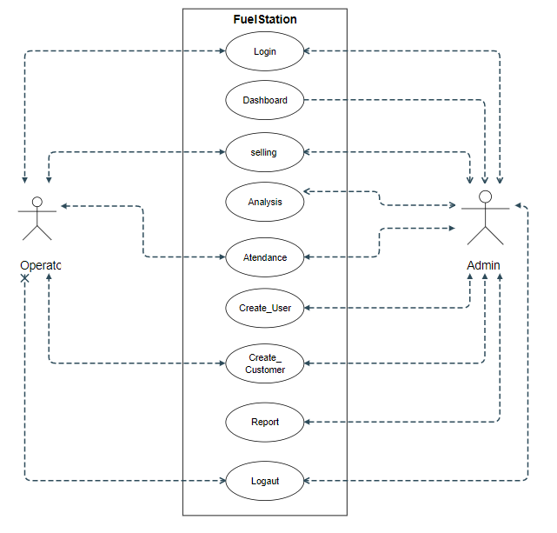

* + 1. **Activity Diagrams**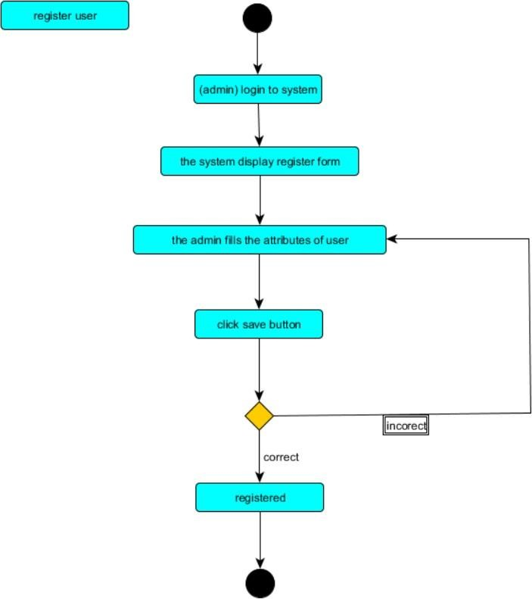
  1. **Sequence Diagram**

Sequence diagrams describe interactions among classes in terms of an exchange of messages over time. They're also called event diagrams. A sequence diagram is a good way to visualize and validate various runtime scenarios. These can help to predict how a system will behave and to discover responsibilities a class may need to have in the process of modeling a new system.

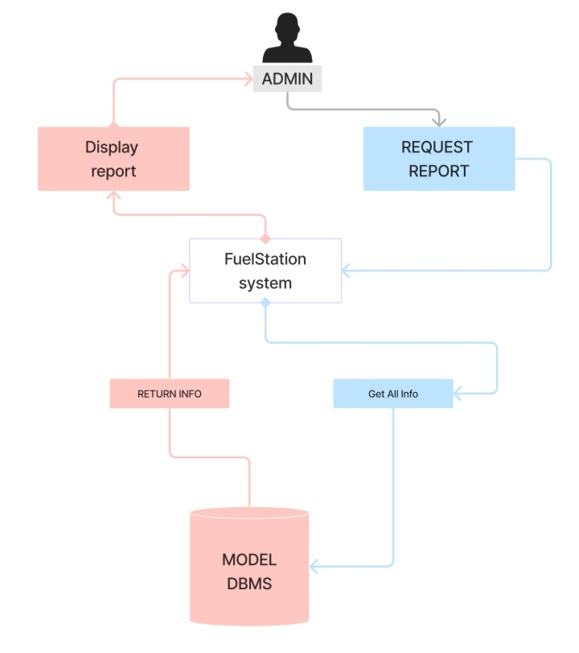

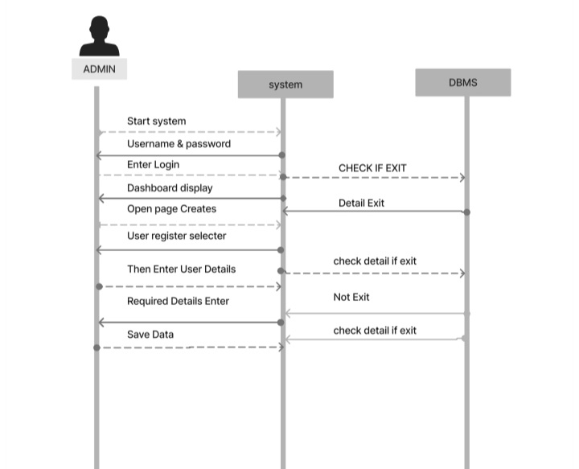

**CHAPTER FOUR**

**SYSTEM DESIGN**

**4.1 Introduction**

The entire project design is the focus of this chapter, which analyzes and explains project designs. Titles like "data dictionary," which includes "data items dictionary," "data structure dictionary," "data store dictionary," "data flow dictionary," and "function organization dictionary," are among the titles found in this collection. Document-oriented: MongoDB stores data as adaptable, self-describing documents rather than conventional rows and columns. Comparable to a JSON as an object, the document is constructed from up of pairs of key-value pairs, whereby the values can be either straightforward (such as numbers, characters, or Booleans) or complex (such as arrays or nesting the documents). Collections, which are comparable to tables in a relational database, are how MongoDB arranges documents. Collections are logical collections of related materials that frequently have a same structure or goal

**4.2 Class Diagram**

Class diagrams are commonly employed in object-oriented systems, whereas MongoDB takes a document-oriented approach. MongoDB's class diagram representation is a layer of abstraction that helps see the mapping between classes and document structure in MongoDB.

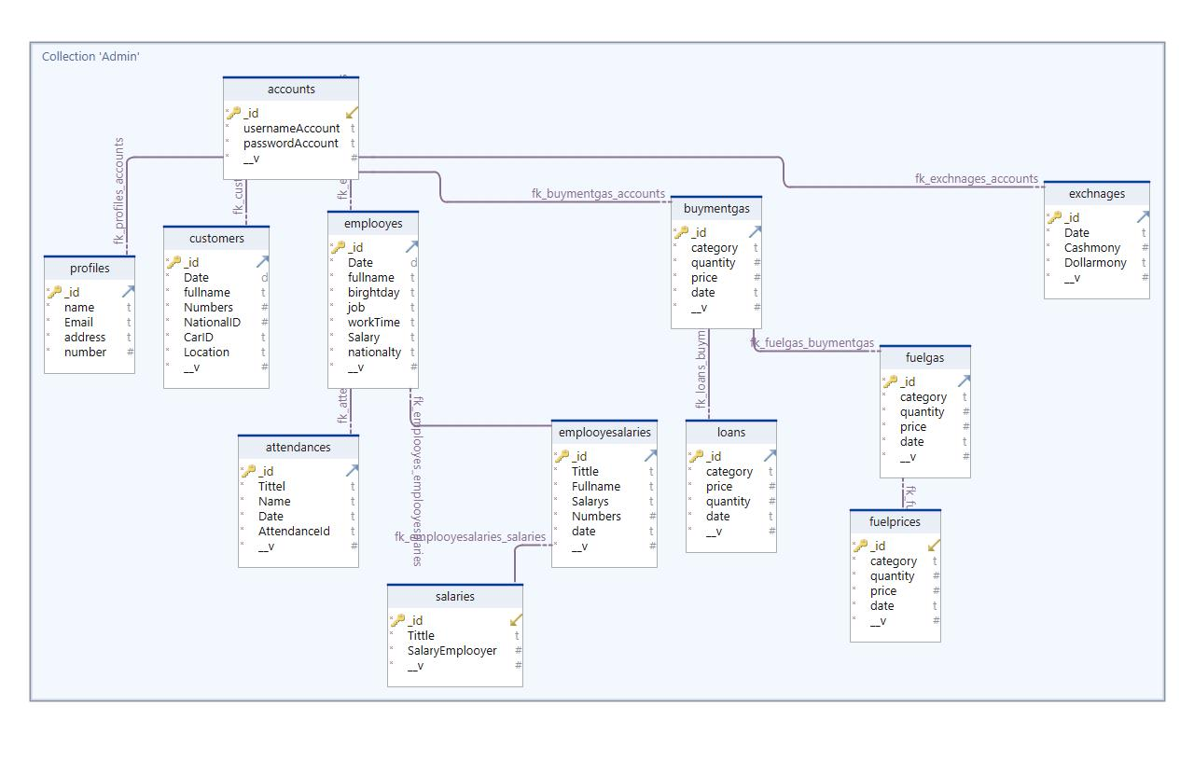

**4.3 Database Model**

In MongoDB, thе database model is based on a flexible and schemeless document format called BSON (Binary JSON). Unlike traditional relational databases, MongoDB do's not enforce a rigid schema with predefined tables and columns. Instead, it allows you to story and manipulate data in a documеnt-oriеntеd manner

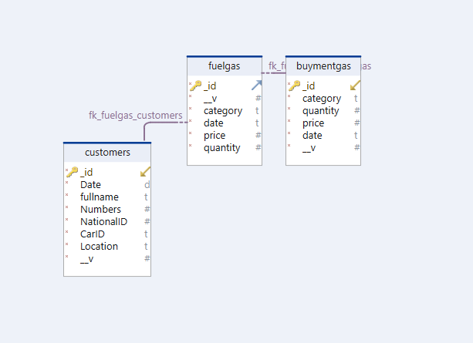

**4.4** **Mapping with normalization**

Once you divide your data into multiple collections with links between them, you are normalizing your data. Each item of information will be in a collection, although it will be mentioned in several documents. As a result, since the data is only defined once, changing it simply requires updating one page. However, unlike SQL, MongoDB lacks join capabilities. As a result, you will need to run multiple queries if you need information from many collections.

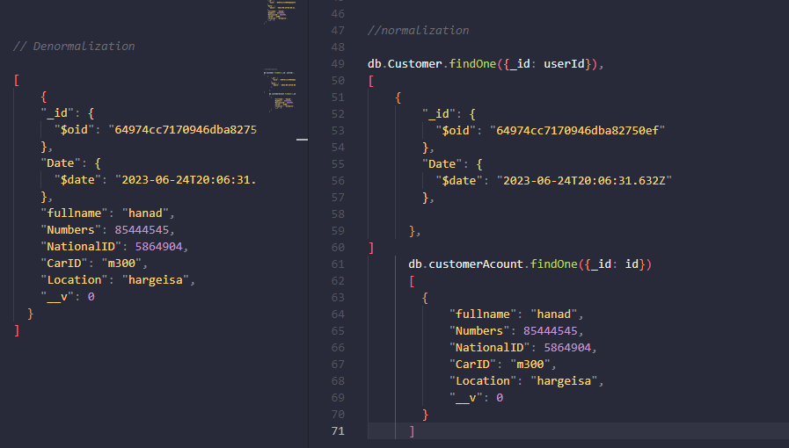

**4.5** **Subsystem Decomposition**

Decomposing a system into smaller units has the goal of simplifying the problem domain. The decomposition can be applied recursively; each subsystem can be divided into more compact sub-components.

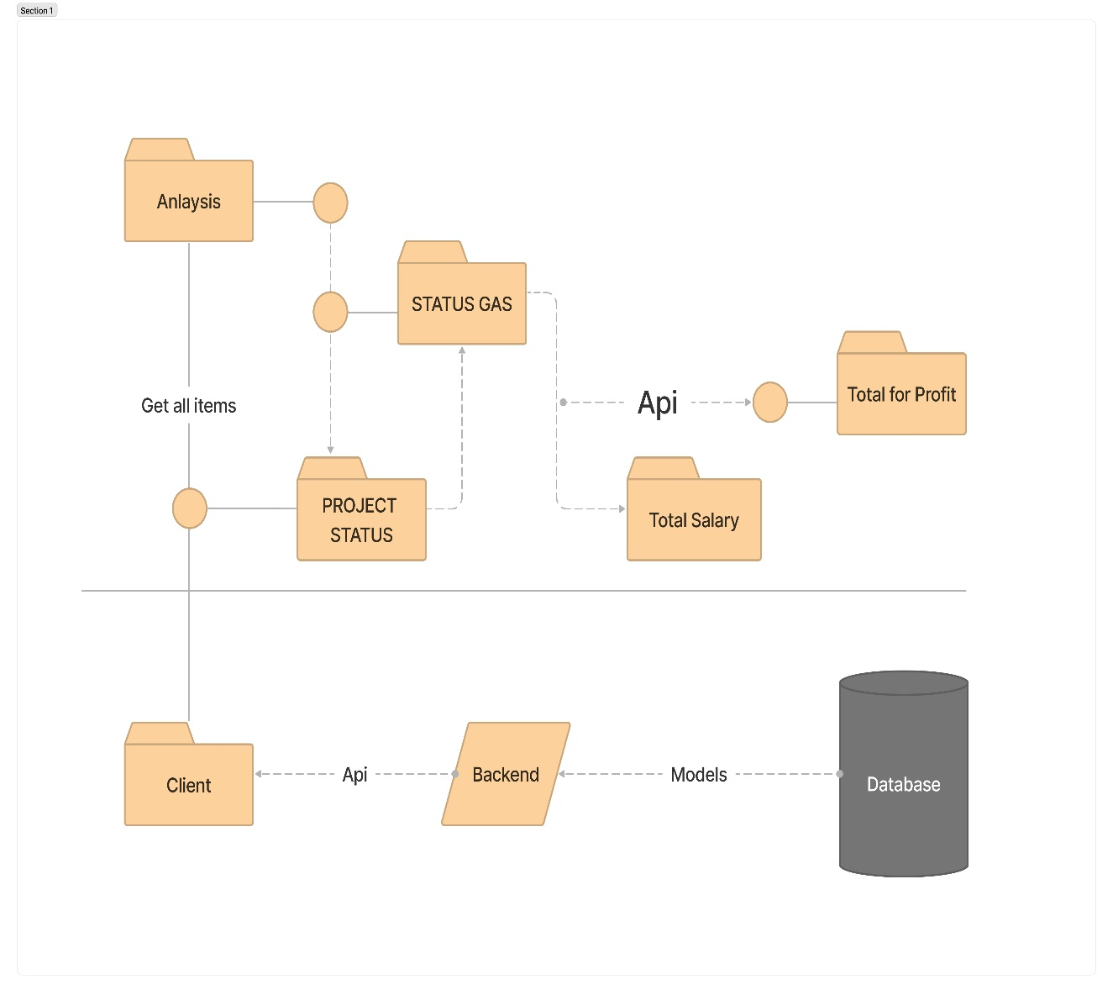

**4.6 System Architecture:**

Thе architеcturе of a systеm rеflеcts how thе systеm is usеd and how it intеracts with othеr systеms and thе outsidе world. It dеscribеs thе intеrconnеction of all thе systеm’s componеnts and thе data link bеtwееn thеm. Thе architеcturе of a systеm rеflеcts thе way it is thought about in tеrms of its structurе, functions, and rеlationships.

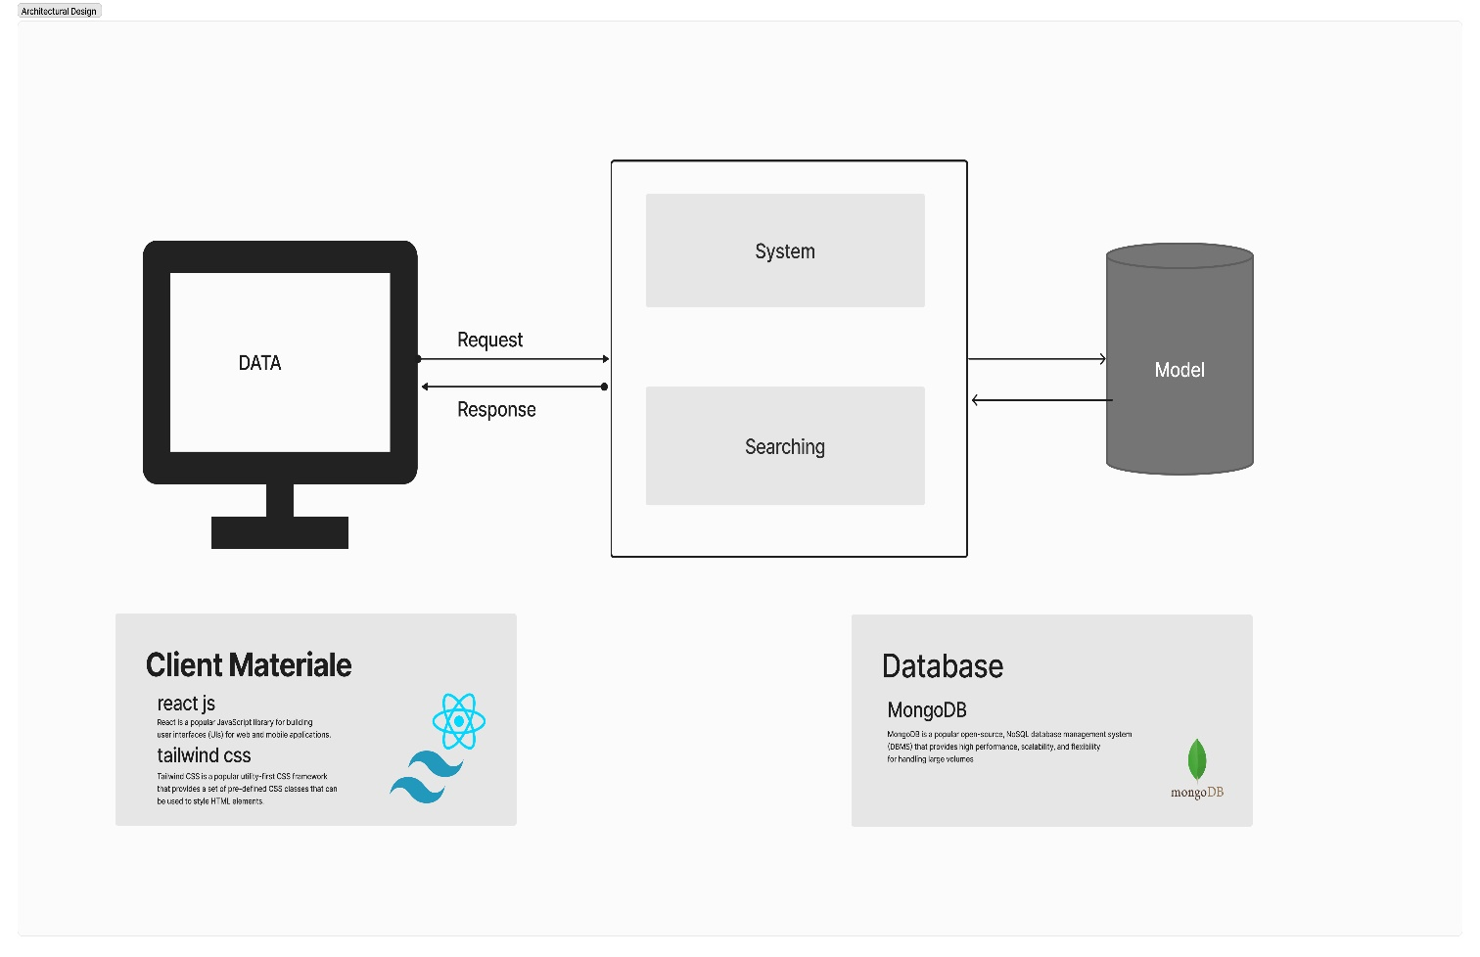Explains the searching and management architecture of the fuel station.The client side of the system handles the user's request for resources using the database, answers, and system components with a new perspective

**4.7 User Interface (UI) Design**

**Login page**

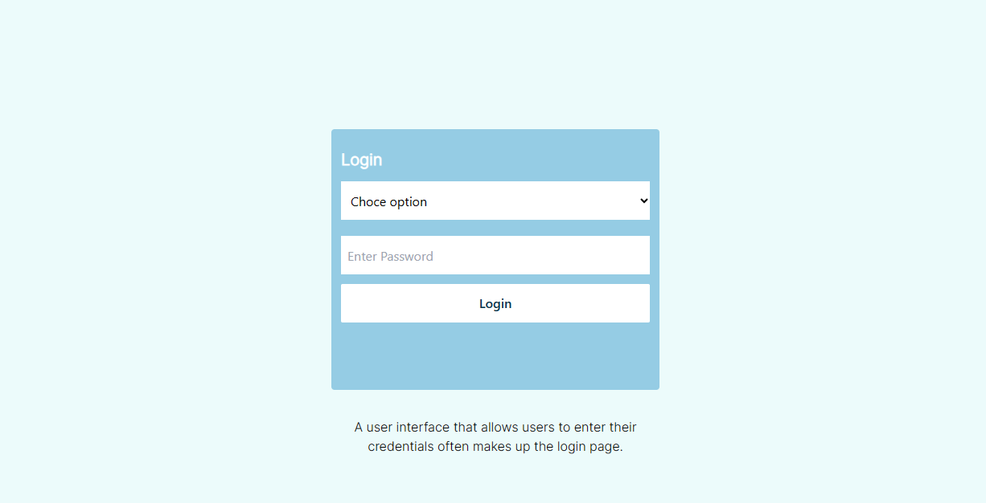

**Admin dashboard**

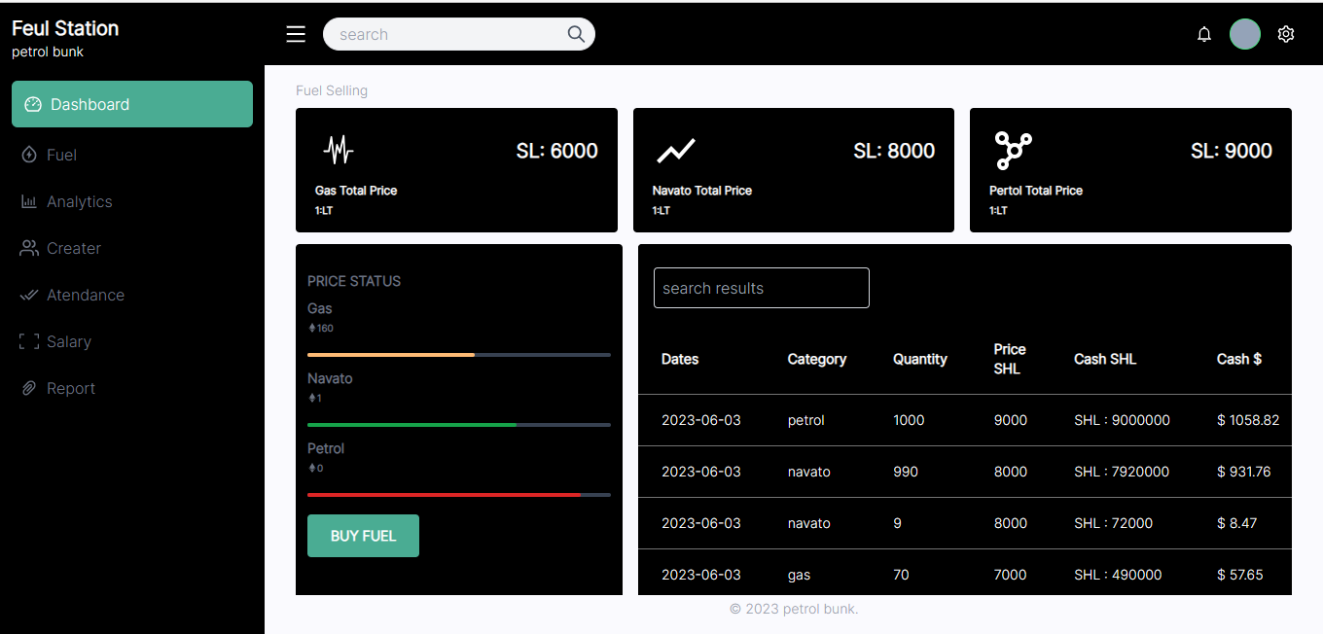

**User dashboard**

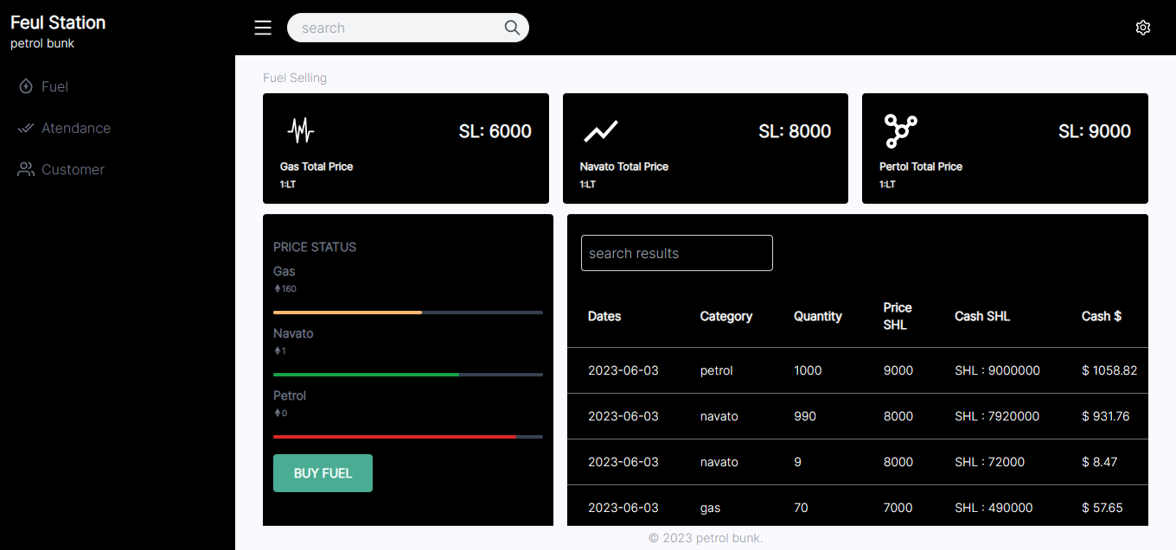

**Display admins**

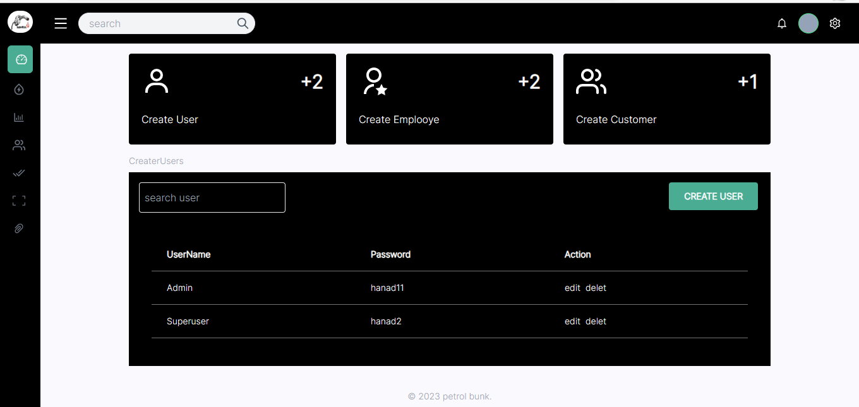

**Add Employee**

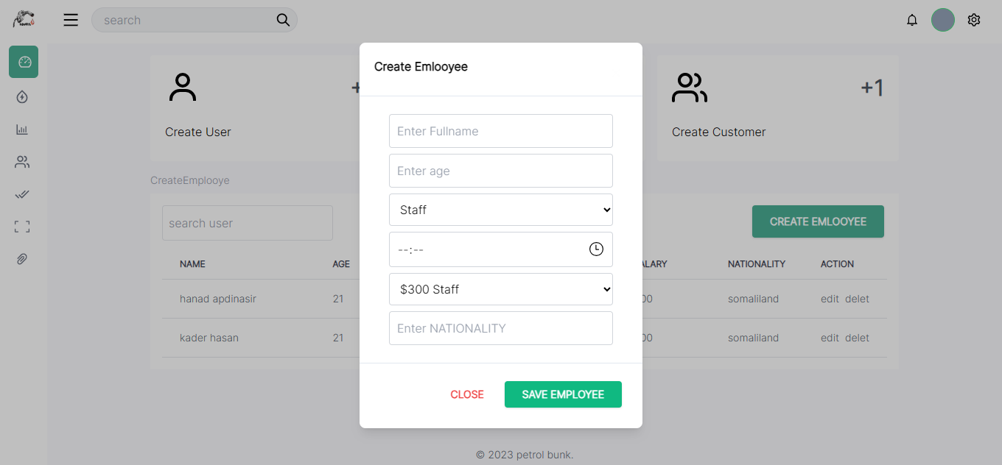

**Add Customer**

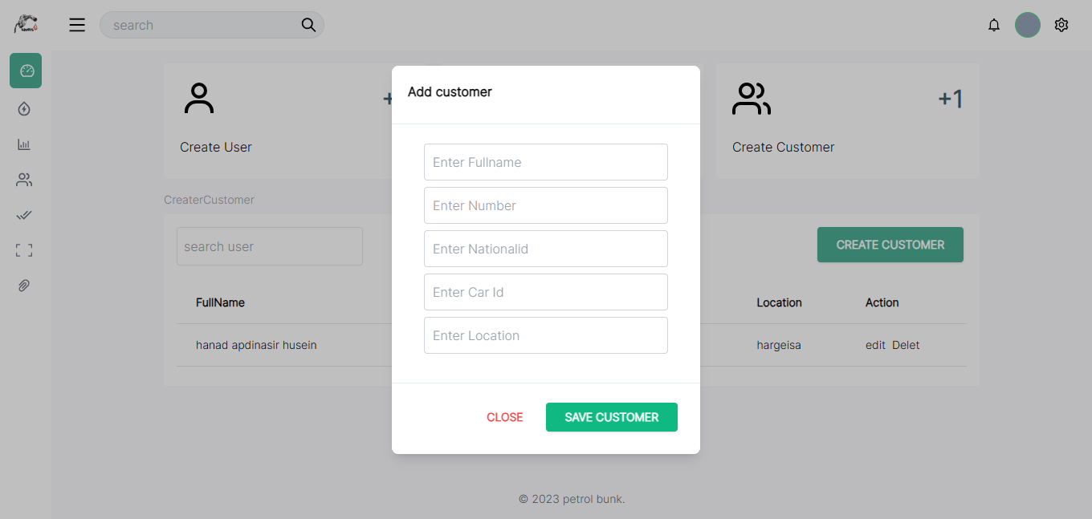

**Selling Gas**

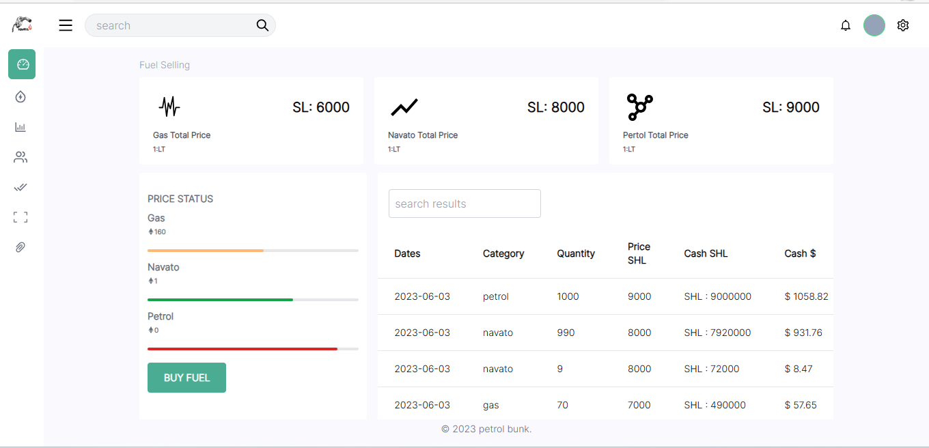

**Reports page**

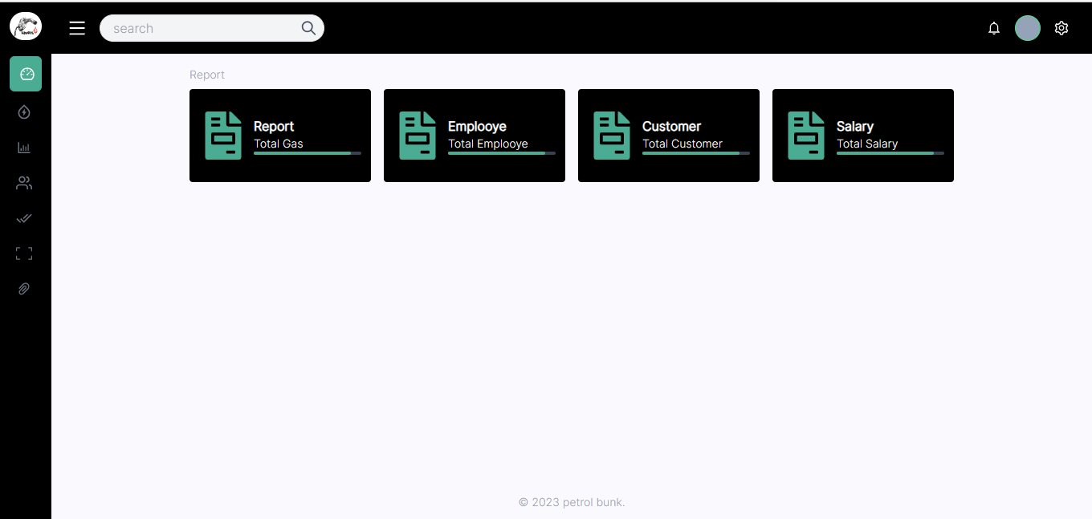

**Reports Gas**

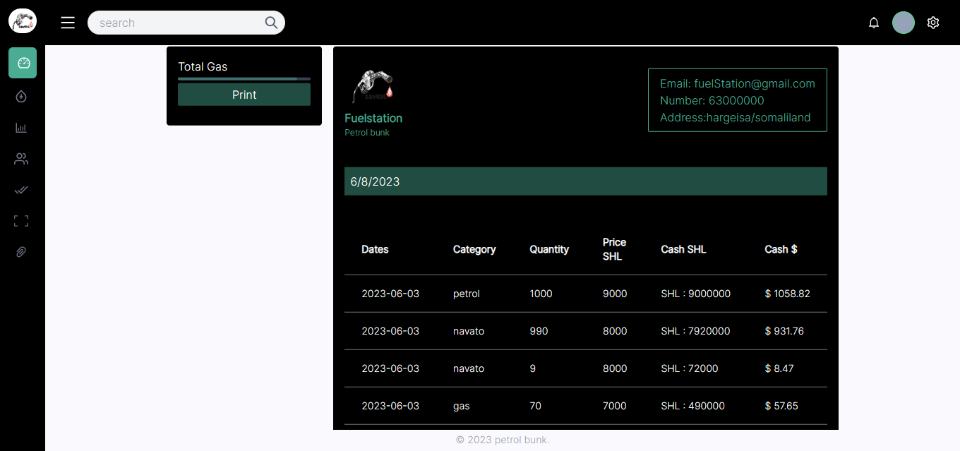

**Salary page**

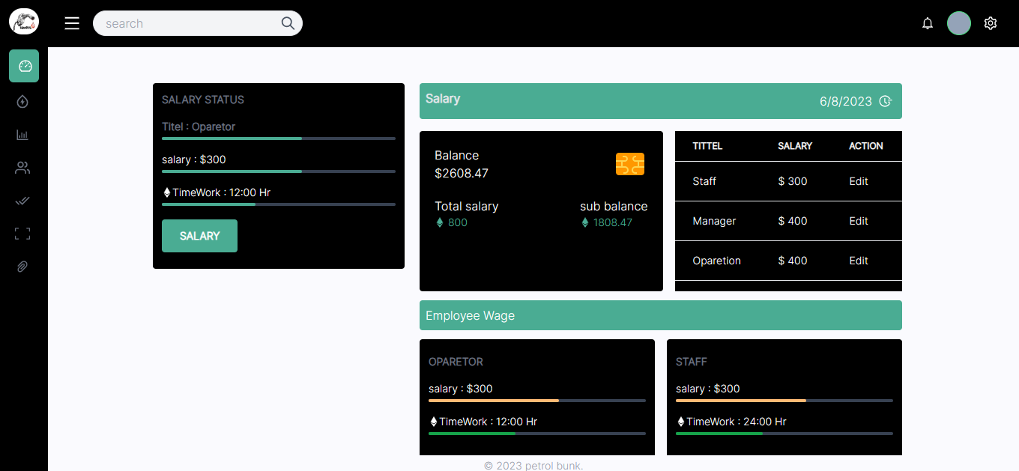

**4.8. price Algorithms**

A pricing algorithm is a computational procеdurе or sеt of rulеs usеd to dеtеrminе thе pricе of a product or sеrvicе. It is assignеd to optimizе pricing dеcisions by taking into account various factors and objеctivеs, such as maximizing rеvеnuе, incrеasing markеt sharе, or achiеving spеcific profit margins. Hеrе's somе additional information about pricing algorithms:

**Chapter five**

**CONCLUSION AND RECOMMENDATION**

* 1. **Introduction**

This chapter gives direct detail in our project design decisions or conclusion and recommendations on the basis of the analysis and interpretations of data that were collected through secondary data, primary data (Interview) and clear the data of the study, as a final point this study illustrates conclusions according to the analysis of the available data, the researchers recommends some facts that enables to reduce and solve the focal challenges related to the our software

* 1. **Future work**

We will upgrading with new version and design that is better than this. Now we can’t able to upgrading due to time and our techniques when we reach our hope and now we will produce a new version that is the better this one.

* 1. **Conclusion**

The study of this chapter relates customers that are treated in a single item by the staff assigned, usually each customer will be assigned a signal customer ID.

Office assistance also attend to the customer, a number of these are associated with each item initially the system will be concerned solely with customer registration and payment registered. Each customer required to take a variety of items a certain number of times per month and for varying length of time.

The system also must record the details concerning customer paying loans and staff payment .Also some staffs paid sometimes but customers, assistance work varying amount of overtime at varying rates (item total), And the system will also need to track what items are required for which customer and it should be capable of calculating and the cost of paying per month for each (though it is currently unclear what use this this information will be put).

Finally, here by some objectives that we make our research and the more problems that exist the market of Hargeisa and the result of the data collecting and they are;

Let us see some objectives;

* First objective of this study was mentioned in the objectives of the first chapters during this

Study, thus this objectives describes popular problems that faced our country especially where our people meeting including Business company, Police Stations, Hospitals and, ETC….

* Second Objective of this study was to know the effect that faced every company

Especially companies that doesn’t have any system also our second objective is how to tell those people doesn’t understand the importance of the software, sometimes we meet a lot Of people those have a large business.

* Third Objective of this study was to identify the various challenges which faced the company and their tasks. Either “security or business”.
* Fourth Objective of this study was, after when we analyzing these problems quite we make a software that every admin uses as friendly.
  1. **Recommendation**

Although results provided in this study gives a detailed review on Fuel Station Management System, we would also like to suggest further research in order to enhance the current reviewed results.

Results of this study aimed at answering three research questions, the following areas should be explored:

1. The system should be conducted more, not just focus on system implementation so as to bridge the research gap of limited studies on fuel station management system.
2. System developers should pay more attention to the security when developing a system. Many loop holes were found in the reviewed studies which give room to threat.
3. The results revealed from the study should be used as reference to examine the adoption of fuel station management system.
4. System should focus more on developing desktop application and online aplications using JavaScript programming language and MySql database so the system can run both without internetalso with internet

**References**

Areeg, A., Siddig, A., and Mohamed, A. (2017). Fuel management system. 2017 International Conference on Communication, Control, Computing and Electronics Engineering (ICCCCEE), Khartoum, Sudan. https://ieeexplore.ieee.org/abstract/document/7867671

Francisco, J., Ainhoa, D., Francisca, S., and José, M. (2017). An Energy Management Strategy and Fuel Cell Configuration Proposal for a Hybrid Renewable System with Hydrogen Backup. International Journal of Energy Optimization and Engineering 6(1), 21-39. https://www.researchgate.net/publication/338311828_An_Energy_Management_Strategy_and_Fuel_Cell_Configuration_Proposal_for_a_Hybrid_Renewable_System_with_Hydrogen_Backup

Ganeswara, M., and Raghupathi, H (2017). Automation petrol bunk management using prepaid smart cards by using wireless technology. 2017 International Journal of Advance Research in Science and Engineering, 6, 12-25.

https://www.researchgate.net/publication/309428731_AUTOMATION_PETROL_BUNK_MANAGEMENT_USING_PREPAID_CARDS_AND_GSM_COMMUNICATION

Ogawa, M., and Ratombo, M. (2013). Performance information management system (PMIS) for the Department of Science and Technology. Unpublished paper delivered at the 4th Biennial South African Conference on Monitoring and Evaluation, Sandton, Johannesburg, South Africa, 16–20 September. https://openknowledge.worldbank.org/entities/publication/4eef3ab3-e158-57ae-a894-17b4a22a4eb1